**Experiment : 2.1**

**Student Name: SANJIV GUPTA UID:** 21BCS-*3478*

**Branch:** CSE **Section/Group:** 21BCS-IOT-602B

**Semester:** 5th **Date:** 22/09/23

**Subject Name**: Advanced Programming LAB **Subject Code:** 21CSP-314

**AIM:**

*To implement the concept of Graphs.*

**OBJECTIVE:**

*1).Consider an undirected graph where each edge weighs 6 units. Each of the nodes is labeled consecutively from 1 to n.*

*You will be given a number of queries. For each query, you will be given a list of edges describing an undirected graph. After you create a representation of the graph, you must determine and report the shortest distance to each of the other nodes from a given starting position using the breadth-first search algorithm (*[*BFS*](https://en.wikipedia.org/wiki/Breadth-first_search)*). Return an array of distances from the start node in node number order. If a node is unreachable, return  for that node.*

*2.) Markov takes out his*[*Snakes and Ladders*](http://en.wikipedia.org/wiki/Snakes_and_Ladders)*game, stares at the board and wonders: "If I can always roll the die to whatever number I want, what would be the least number of rolls to reach the destination?"*

***Rules****The game is played with a cubic die of 6 faces numbered 1 to 6.*

1. *Starting from square 1 , land on square 100 with the exact roll of the die. If moving the number rolled would place the player beyond square 100 , no move is made.*
2. *If a player lands at the base of a ladder, the player must climb the ladder. Ladders go up only.*
3. *If a player lands at the mouth of a snake, the player must go down the snake and come out through the tail. Snakes go down only.*

**CODE:**

**Code 1:**

*vector<int> bfs(int n, int m, vector<vector<int>> edges, int s) {*

*int dist[n];*

*map<int,vector<int>>mp;*

*for(auto x:edges)*

*{*

*mp[x[0]].push_back(x[1]);*

*mp[x[1]].push_back(x[0]);*

*}*

*for (int i=1;i<=n;i++){*

*dist[i] = INT_MAX;*

*}*

*priority_queue<pair<int,int>,vector<pair<int,int>>,greater<pair<int,int>>>pq;*

*pq.push({0,s});*

*dist[s] = 0;*

*while(!pq.empty())*

*{*

*int cost = pq.top().first;*

*int src = pq.top().second;*

*pq.pop();*

*for(auto x: mp[src])*

*{*

*if(dist[x] > cost +6)*

*{*

*dist[x] = cost+6;*

*pq.push({dist[x],x});*

*}*

*}*

*}*

*vector<int>ans;*

*for(int i=1;i<=n;i++)*

*{*

*if(i==s)*

*{*

*continue;*

*}*

*else if(dist[i] == INT_MAX)*

*{*

*ans.push_back(-1);*

*}*

*else {*

*ans.push_back(dist[i]);*

*}*

*}*

*return ans;*

*}*

**Code 2**

*int quickestWayUp(vector<vector<int>> ladders, vector<vector<int>> snakes) {*

*map<int,int> ladd, snak;*

*for(auto &it: ladders) ladd[it[0]] = it[1];*

*for(auto &it: snakes) snak[it[0]] = it[1];*

*queue<pair<int,int>> q;*

*vector<int> vis(101,0);*

*q.push({1,0});*

*vis[1] = 1;*

*vector<int> dist(101,INT_MAX);*

*while(!q.empty()){*

*int nd = q.front().first;*

*int tym = q.front().second;*

*q.pop();*

*for(int i=1; i<=6;i++){*

*int nxt = nd + i;*

*if(ladd[nxt]) nxt = ladd[nxt];*

*if(snak[nxt]) nxt = snak[nxt];*

*if(vis[nxt]) continue;*

*if(nxt == 100) return tym+1;*

*if(!vis[nxt]) vis[nxt] = 1;*

*q.push({nxt,tym+1});*

*}*

*}*

*return -1;*

*}*

**OUTPUT:**

**OUTPUT 1**

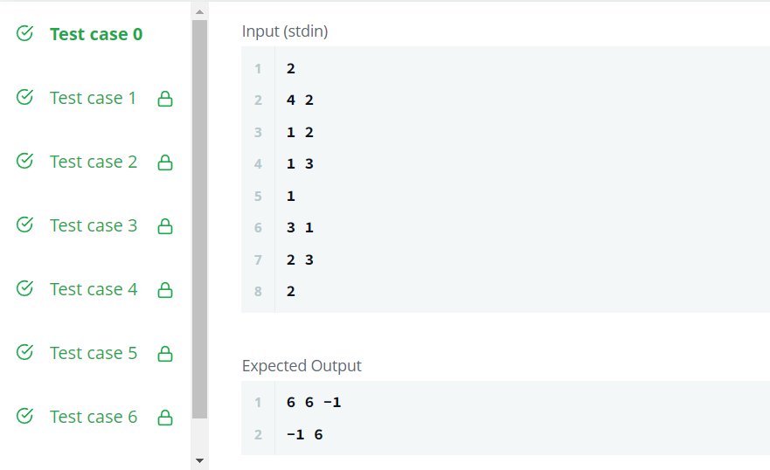

**OUTPUT 2**

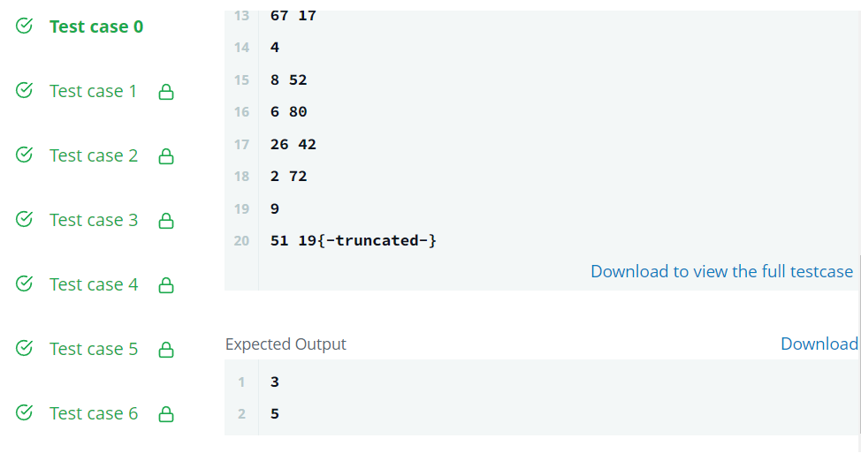

**LEARNING OUTCOMES:**

1. *Understood the concept of Graph.*
2. *Understood the concept how to search in graph and perform different operations.*
3. *Learn about algorithm thinking*
4. *Learn about mathematical logic*